Test Case: tc001_SPX_Dev5_Crear_Solicitud_Articulo_Almacen
Step 1 - Enter username and password and click to button Enter : Credentials Entered
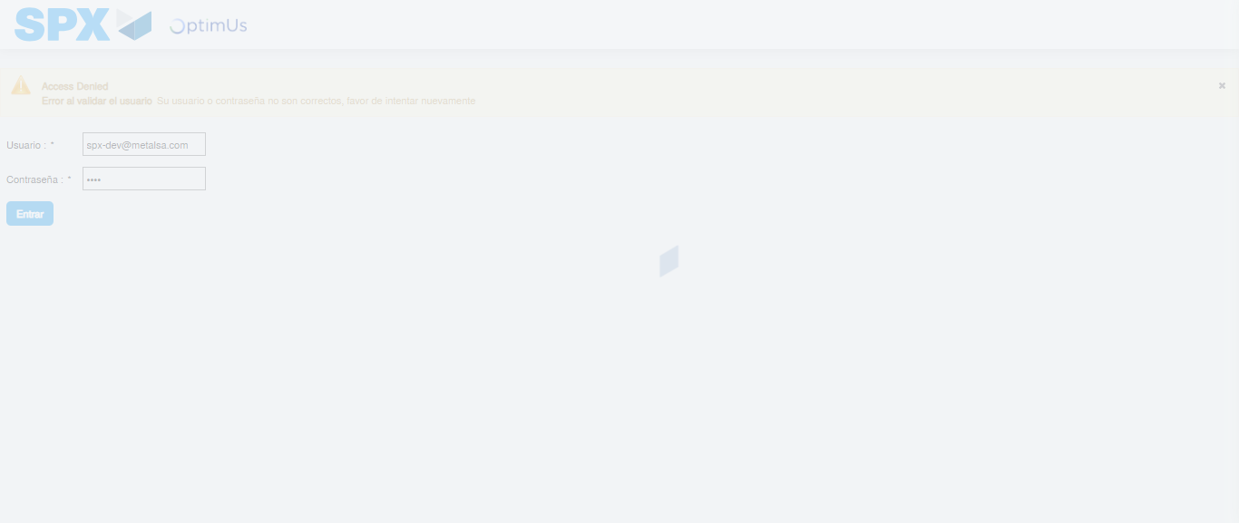Image file-name: QC_Testing-tc001_SPX_Dev5_Crear_Solicitud_Articulo_Almacen-1788279611393

Step 2 - Select to UEN and Access to Request for a New Inventory Item : UEN Correctly selected and Correct access
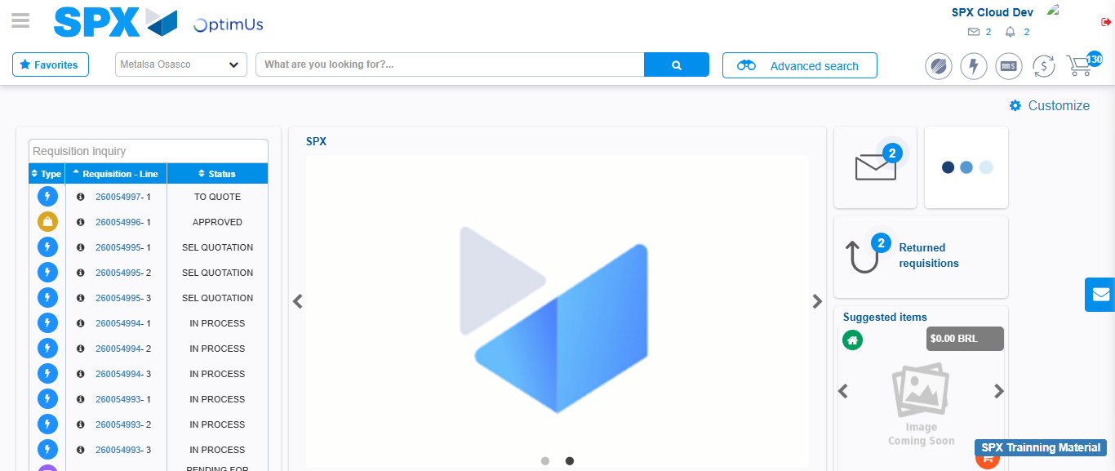Image file-name: QC_Testing-tc001_SPX_Dev5_Crear_Solicitud_Articulo_Almacen-1788279637811

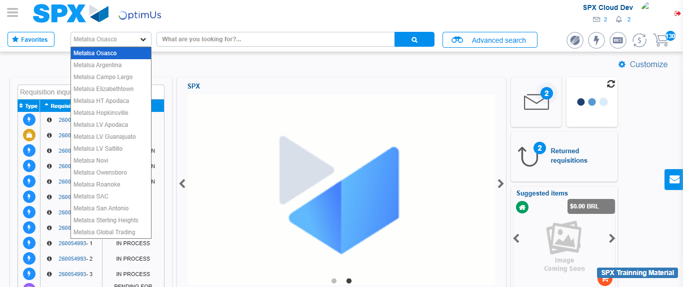Image file-name: QC_Testing-tc001_SPX_Dev5_Crear_Solicitud_Articulo_Almacen-1788279638819

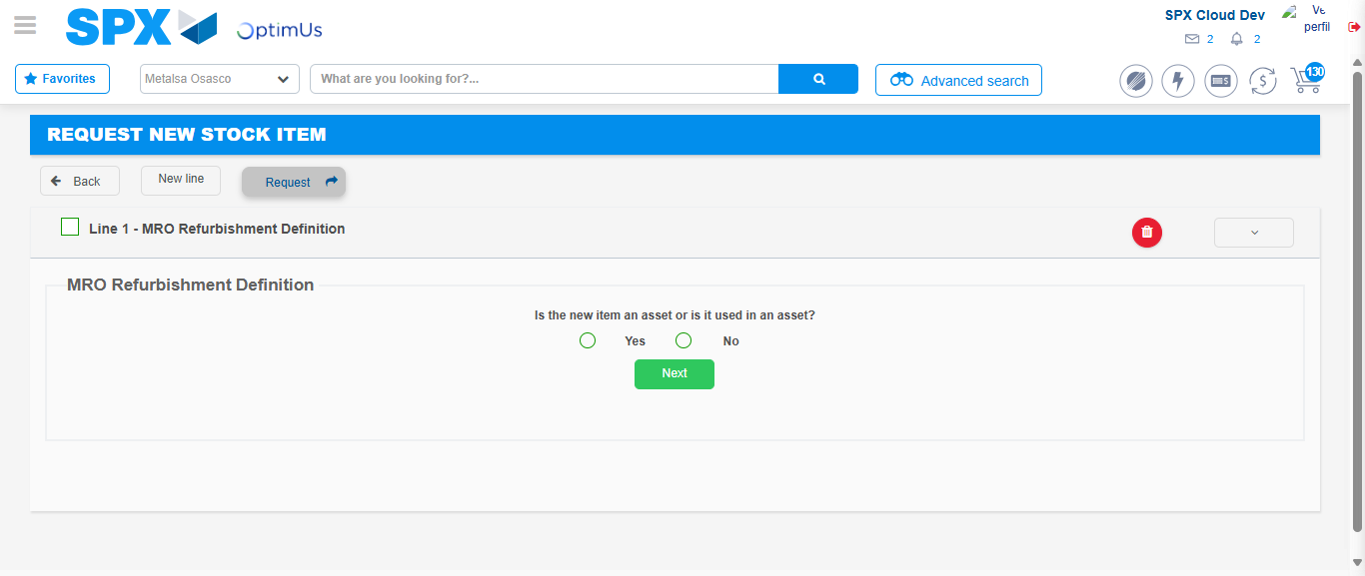Image file-name: QC_Testing-tc001_SPX_Dev5_Crear_Solicitud_Articulo_Almacen-1788279663125

Step 3 - Select options first section : Options seleted correctly
Image file-name: QC_Testing-tc001_SPX_Dev5_Crear_Solicitud_Articulo_Almacen-1788279663479

Image file-name: QC_Testing-tc001_SPX_Dev5_Crear_Solicitud_Articulo_Almacen-1788279663740

Step 4 - Select options at Screen: Options seleted correctly
Image file-name: QC_Testing-tc001_SPX_Dev5_Crear_Solicitud_Articulo_Almacen-1788279663479

Image file-name: QC_Testing-tc001_SPX_Dev5_Crear_Solicitud_Articulo_Almacen-1788279663740

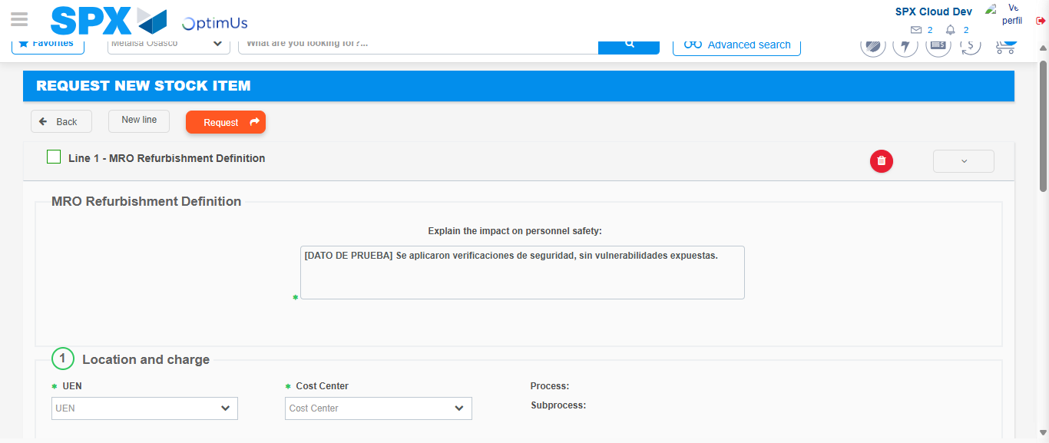Image file-name: QC_Testing-tc001_SPX_Dev5_Crear_Solicitud_Articulo_Almacen-1788279671402

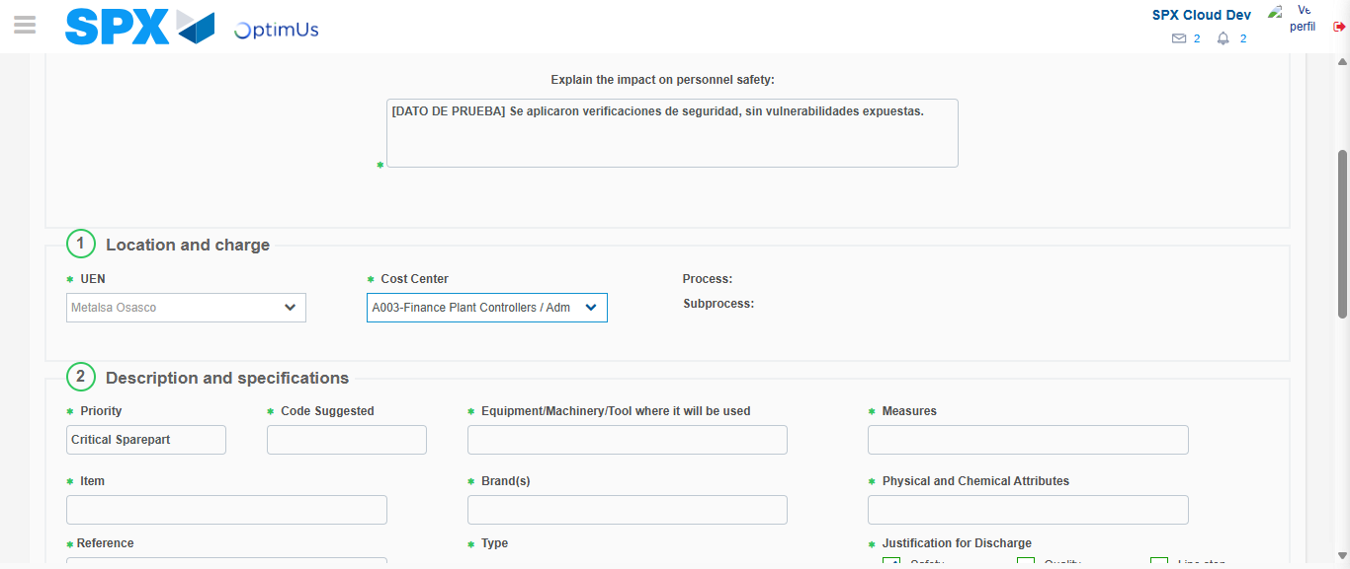Image file-name: QC_Testing-tc001_SPX_Dev5_Crear_Solicitud_Articulo_Almacen-1788279675527

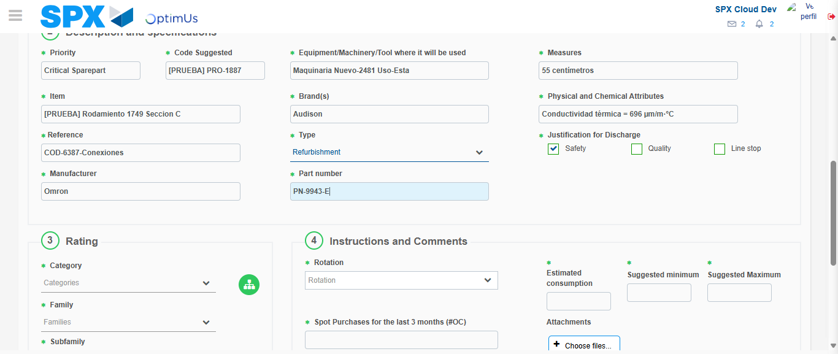Image file-name: QC_Testing-tc001_SPX_Dev5_Crear_Solicitud_Articulo_Almacen-1788279678409

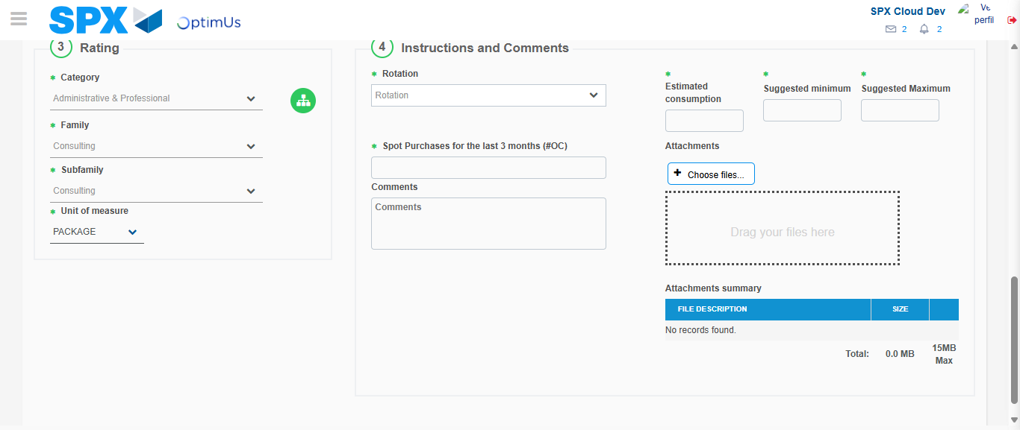Image file-name: QC_Testing-tc001_SPX_Dev5_Crear_Solicitud_Articulo_Almacen-1788279684191

Step 5 - Request New Item : Request Accepted
Image file-name: QC_Testing-tc001_SPX_Dev5_Crear_Solicitud_Articulo_Almacen-1788279637811

Image file-name: QC_Testing-tc001_SPX_Dev5_Crear_Solicitud_Articulo_Almacen-1788279638819

Image file-name: QC_Testing-tc001_SPX_Dev5_Crear_Solicitud_Articulo_Almacen-1788279663125

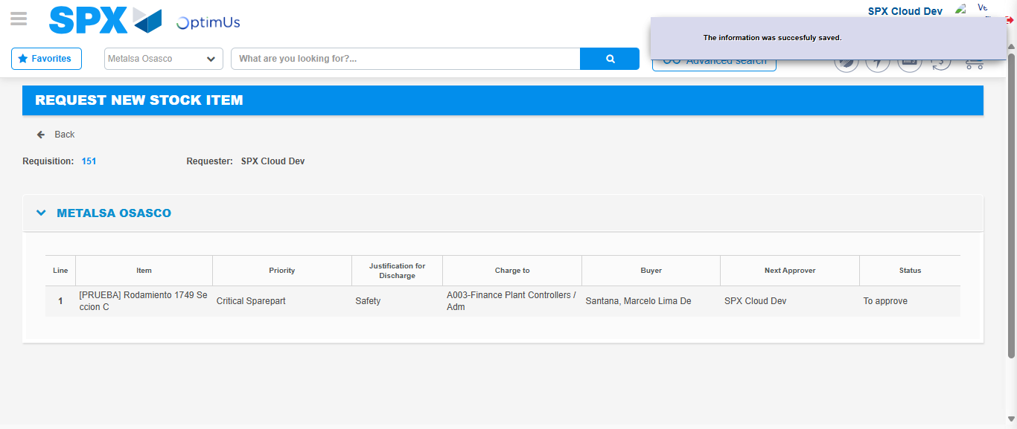Image file-name: QC_Testing-tc001_SPX_Dev5_Crear_Solicitud_Articulo_Almacen-1788279692210

Image file-name: QC_Testing-tc001_SPX_Dev5_Crear_Solicitud_Articulo_Almacen-1788279692480

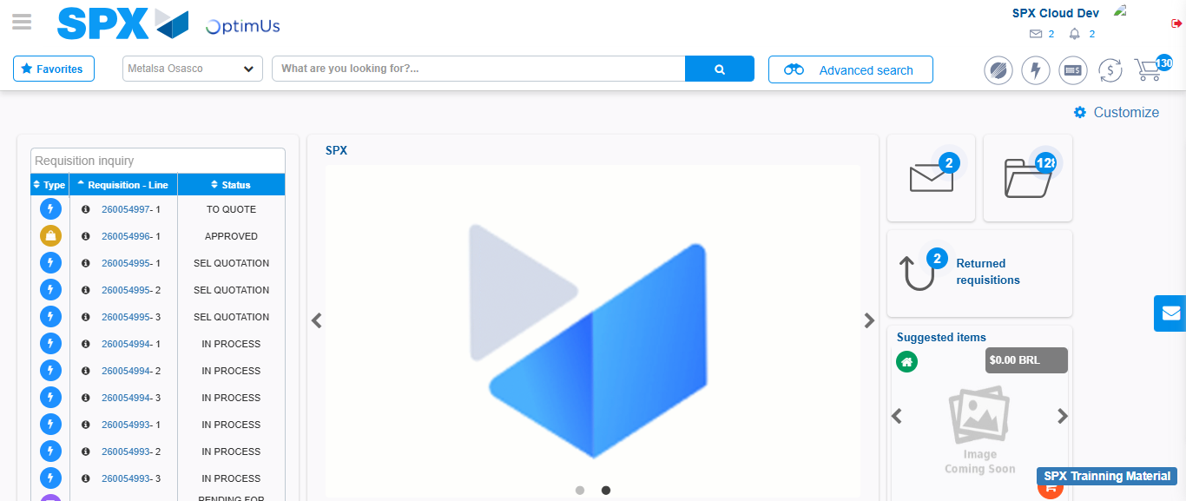Image file-name: QC_Testing-tc001_SPX_Dev5_Crear_Solicitud_Articulo_Almacen-1788279714083

Step 7 - Return to Main Page SPX : Return to Main Page SPX
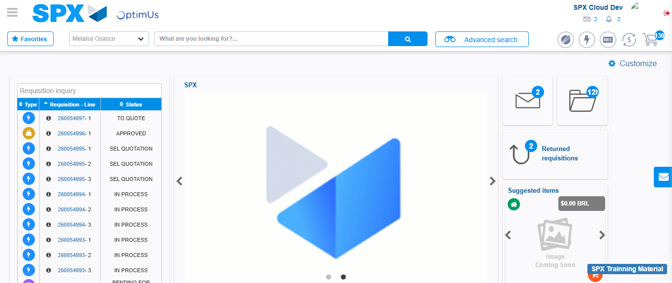Image file-name: QC_Testing-tc001_SPX_Dev5_Crear_Solicitud_Articulo_Almacen-1788279714541

